

Requirement Analysis and usability phase

Assignment no. 3



Nabeel Siddiqui 14682

Shahzaib Gauhar 14944

Wali Ullah 42318

## **PHASE 3: REQUIREMENT ANALYSIS**

* **FUNCTIONAL AND NON FUNCTIONAL REQUIREMENTS**

|  |  |  |  |  |
| --- | --- | --- | --- | --- |
| **No.** | **Requirement** | **Feature** | **SS/**  **CS** | **F/**  **NF** |
| 1 | Client needs to be always connected to the server. | All | CS | F |
| 2 | Client should have an interface for the customer to enter login information. | Login | CS | NF |
| 3 | Client must send login information to the server to be checked. | Login | CS | F |
| 4 | Server must check the sent login information by the client and respond to the client. | Login | SS | F |
| 5 | Client should be able to display list of categories and click on them for browsing. | Browse category | CS | NF |

|  |  |  |  |  |
| --- | --- | --- | --- | --- |
|  |  |  |  |  |
| 6 | Client must send the clicked category’s identification to the server. | Browse category | CS | F |
| 7 | Server must provide the selected category’s content list for the client. | Browse category | SS | F |
| 8 | Client should have an interface for the customer to enter special keywords to search a product. | Search products | CS | NF |
| 9 | Client must send the entered keywords to the server. | Search products | CS | F |
| 10 | Server must compare the sent keyword with products list and respond. | Search products | SS | F |
| 11 | Client should be able to display a product’s description such as name, model, image, price and details. | View products description | CS | NF |
| 12 | Server must provide the selected product’s description for the client. | View products description | SS | F |
| 13 | Client should have an interface for the customer to add a product to the shopping cart. | Add products to the cart | CS | NF |
| 14 | Client must send the clicked product’s identification to the server. | Add products to the cart | CS | F |
| 15 | Server should add the product to the customer’s shopping cart on the database. | Add products to the cart | SS | F |
| 16 | Server should be able to check a product’s quantity on the database. | Check item quantity | SS | F |
| 17 | Client should have an interface for the customer to remove an already added product on the shopping cart. | Remove product from cart | CS | NF |
| 18 | Client must send the removed product’s identification to the server. | Remove product from cart | CS | F |
| 19 | Server should remove the product from customer’s shopping cart on the database. | Remove product from cart | SS | F |
| 20 | Client should have an interface for the customer to change the quantity of an already added product on the shopping cart. | Change quantity | CS | NF |
| 21 | Client must send the new quantity and the product’s identification to the server. | Change quantity | CS | F |
| 22 | Server must update the customer’s shopping cart content on the database. | Change quantity | SS | F |
| 23 | Client should have an interface for the customer to checkout and view the checkout receipt. | Checkout | CS | NF |
| 24 | Client must send the customer’s identification to the server. | Checkout | CS | F |
| 25 | Server must provide the customer’s checkout receipt for the client. | Checkout | SS | F |
| 26 | Client should have an interface for the customer to view the payment method’s authentication and enter required credentials. | Payment method | CS | NF |
| 27 | Client must send the provided credentials to the server. | Payment method | CS | F |
| 28 | Server must perform the money transfer and send back a confirmation. | Payment method | SS | F |
| 29 | Server must update the database with the required checkout processes. | Payment method | SS | F |
| 30 | Client must be provided bank payment method as well as Cash on Delivery method. | Payment method | CS | NF |
| 31 | Client should be able to see order details (Delivery time, amount, delivery type and etc. | Placing Order | CS | NF |
| 32 | Client should be provided a free view for window shopping. | View Products | CS | NF |
| 33 | View should be optimized for portrait and landscape mode. | All | CS | NF |
| List of Abbreviations  No. Number  SS Server side  CS Client side  F Functional  NF Non-Functional | |  |  |  |

* **USE CASE DIAGRAM AND ITS NARRATIVES**

**USE CASE DIAGRAM:**

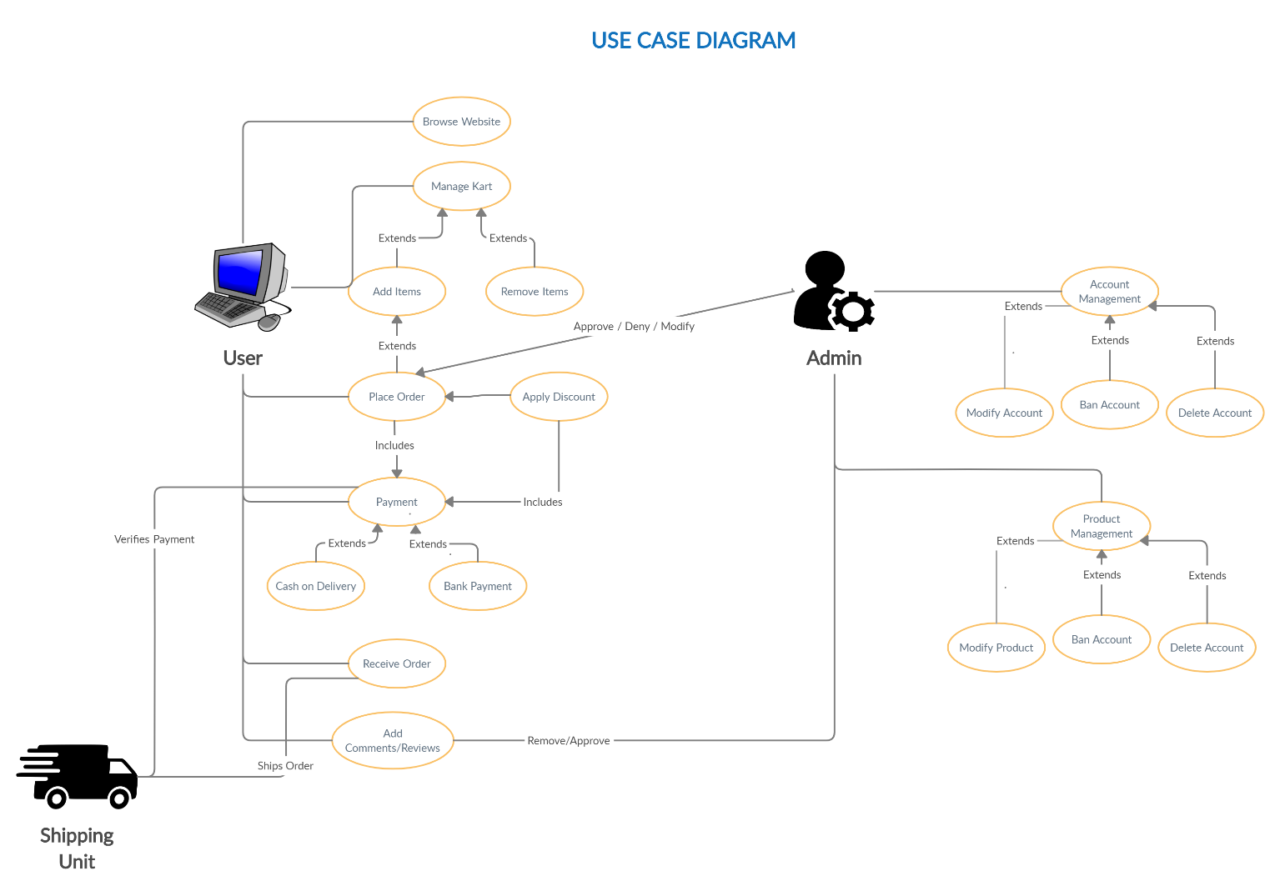

**USE CASE WITH ITS NARRATIVES:**

**Sub use cases with narratives**

* 1. **User Login to the system**

|  |  |  |
| --- | --- | --- |
| **Use Case Name:** | Login | |
| **ID:** | OM-01 | |
| **Actors Involved:** | Customer, Administrator | |
| **Brief Description** | Actor enters the email address and password to login to the system. | |
| **Pre-Conditions** |  | |
| **Post-Conditions** |  | |
| **Normal Flow of Events:** | **Actor Action** | **System Response** |
| 1. Enter email address and password. 2. Clicks the submit button. | 1. System displays the actor mail page on successful login. 2. System displays error message on invalid login. |

* 1. **User Adds to Cart**

|  |  |  |
| --- | --- | --- |
| **Use Case Name:** | User Cart | |
| **ID:** | OM-02 | |
| **Actors Involved:** | Customer | |
| **Brief Description** | Actor Adds/Removes products from the cart. | |
| **Pre-Conditions** | OM-01 | |
| **Post-Conditions** | Addition/Removal of products from user cart. | |
| **Normal Flow of Events:** | **Actor Action** | **System Response** |
| 1. Click on “Add to cart” on products 2. Click “Remove” option in the user cart page. 3. Click “Clear Cart” in the User Cart page. | 1. System adds the product into the cart. 2. System deletes the product from the cart. 3. System clears all the products in the cart. |

* 1. **User makes payment**

|  |  |  |
| --- | --- | --- |
| **Use Case Name:** | Payment | |
| **ID:** | OM-03 | |
| **Actors Involved:** | Customer | |
| **Brief Description** | Make payment for the product | |
| **Pre-Conditions** | OM-02 | |
| **Post-Conditions** | Approval of the user order. | |
| **Normal Flow of Events:** | **Actor Action** | **System Response** |
| 1. Go to the cart and click “Proceed to checkout” 2. Select payment method (COD or Bank) 3. Click on “Order Now” | 1. System navigates to checkout. 2. System sets the desired payment method. 3. System generates the amount receipt and place order by using selected payment method. |

* 1. **User adds reviews**

|  |  |  |
| --- | --- | --- |
| **Use Case Name:** | Adding Review | |
| **ID:** | OM-04 | |
| **Actors Involved:** | Customer | |
| **Brief Description** | User adds review to the product. | |
| **Pre-Conditions** | OM-03 | |
| **Post-Conditions** | Review added to the product. | |
| **Normal Flow of Events:** | **Actor Action** | **System Response** |
| 1. Hover at the bottom of the product, fill the textbox and grading. 2. Click on “Submit review” | 1. - 2. System publishes the review to the product. |

* 1. **Administrator deletes review**

|  |  |  |
| --- | --- | --- |
| **Use Case Name:** | Deleting Review | |
| **ID:** | OM-05 | |
| **Actors Involved:** | Administrator | |
| **Brief Description** | Removing reviews from the product. | |
| **Pre-Conditions** | OM-04 | |
| **Post-Conditions** | Deletes review from the product. | |
| **Normal Flow of Events:** | **Actor Action** | **System Response** |
| 1. Hover at the bottom of the product 2. Click on “Delete Review” | 1. - 2. System deletes the review from the page. |

* 1. **Administrator Rejects Order**

|  |  |  |
| --- | --- | --- |
| **Use Case Name:** | Rejecting Order | |
| **ID:** | OM-06 | |
| **Actors Involved:** | Administrator | |
| **Brief Description** | Removing the user order(s). | |
| **Pre-Conditions** | OM-03 | |
| **Post-Conditions** | User order gets rejected. | |
| **Normal Flow of Events:** | **Actor Action** | **System Response** |
| 1. Hover to the admin panel 2. Select the order to be rejected, place the reason in the textbox and click on “Reject”. | 1. System navigates to Admin panel 2. System will delete the order and send a corresponding notification to the user with the reason. |

* 1. **Account Management**

|  |  |  |
| --- | --- | --- |
| **Use Case Name:** | Account Management | |
| **ID:** | OM-07 | |
| **Actors Involved:** | Administrator | |
| **Brief Description** | Managing user account (Performing Ban, Delete and Modify functions) | |
| **Pre-Conditions** |  | |
| **Post-Conditions** |  | |
| **Normal Flow of Events:** | **Actor Action** | **System Response** |
| 1. Hover to the admin Panel. 2. Search/Select the user account to be managed. 3. Click on Ban / Delete / Modify account to process relevant function. | 1. System navigates to Admin panel. 2. System selects the account(s). 3. System deletes/Bans/Modifies the account. |

* **ENTITY RELATIONSHIP DAIGRAM(ERD)**

**ERD:**

**Discription:**

ERD for our client’s online mart project

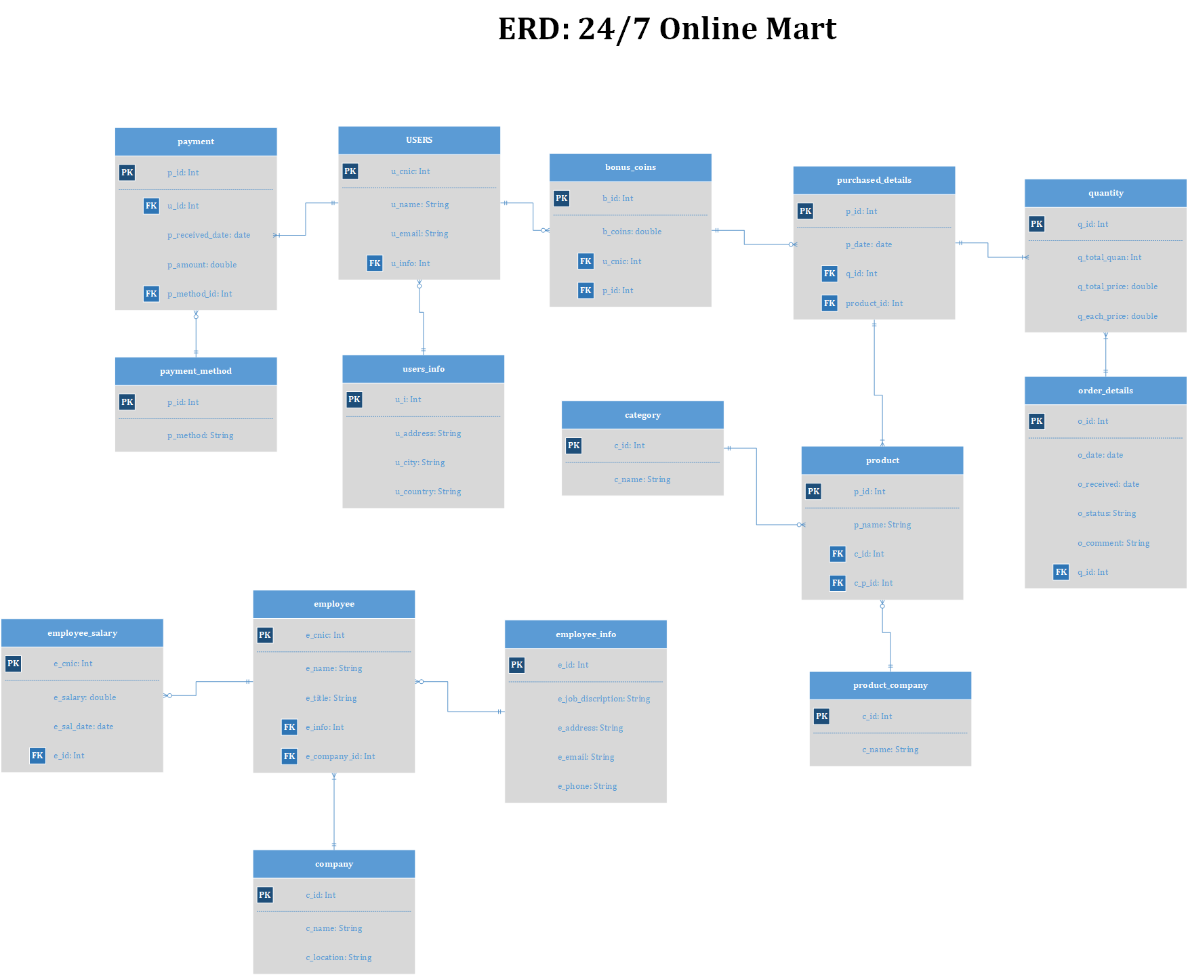

## **PHASE 4: USABILITY PHASE**

1. **PAPER PROTOTYPE**

**PROTOTYPES:**

* **Application Menu:**

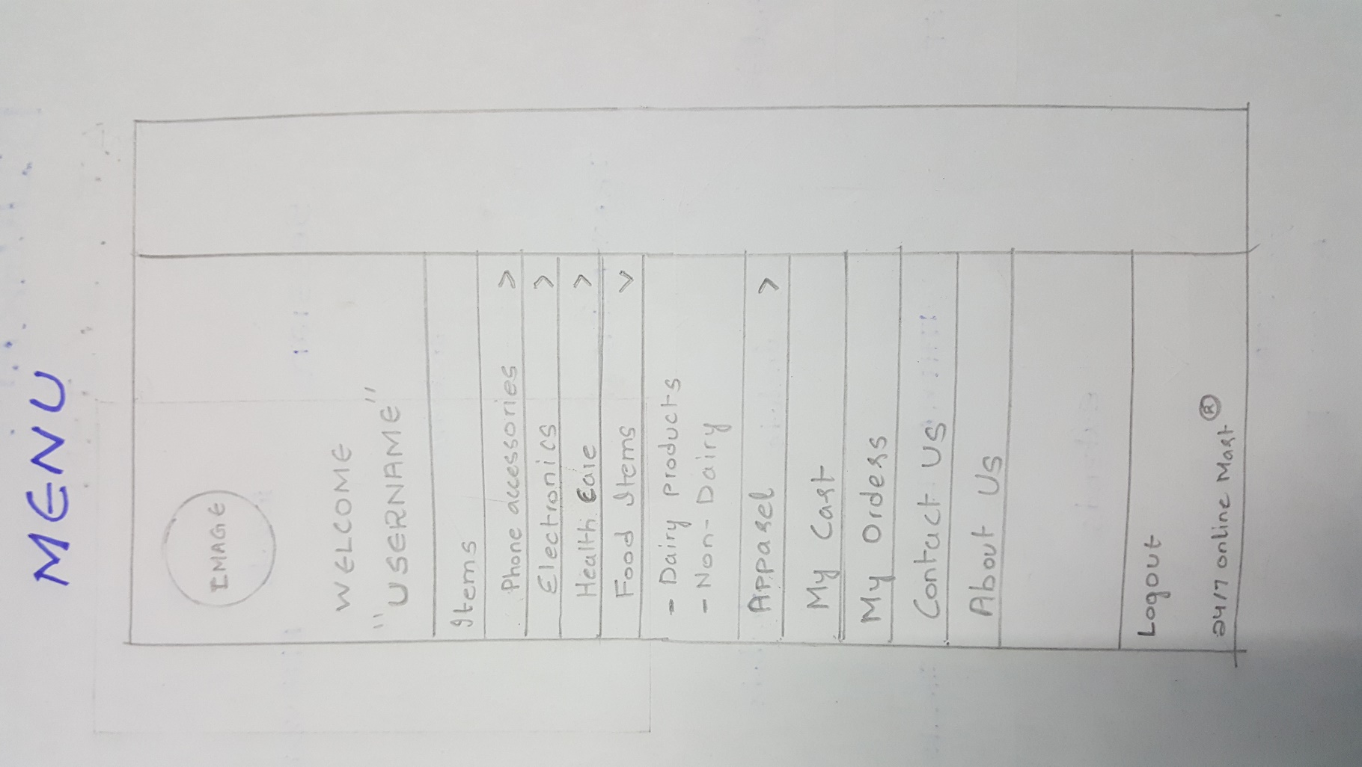

* **Category Page:**

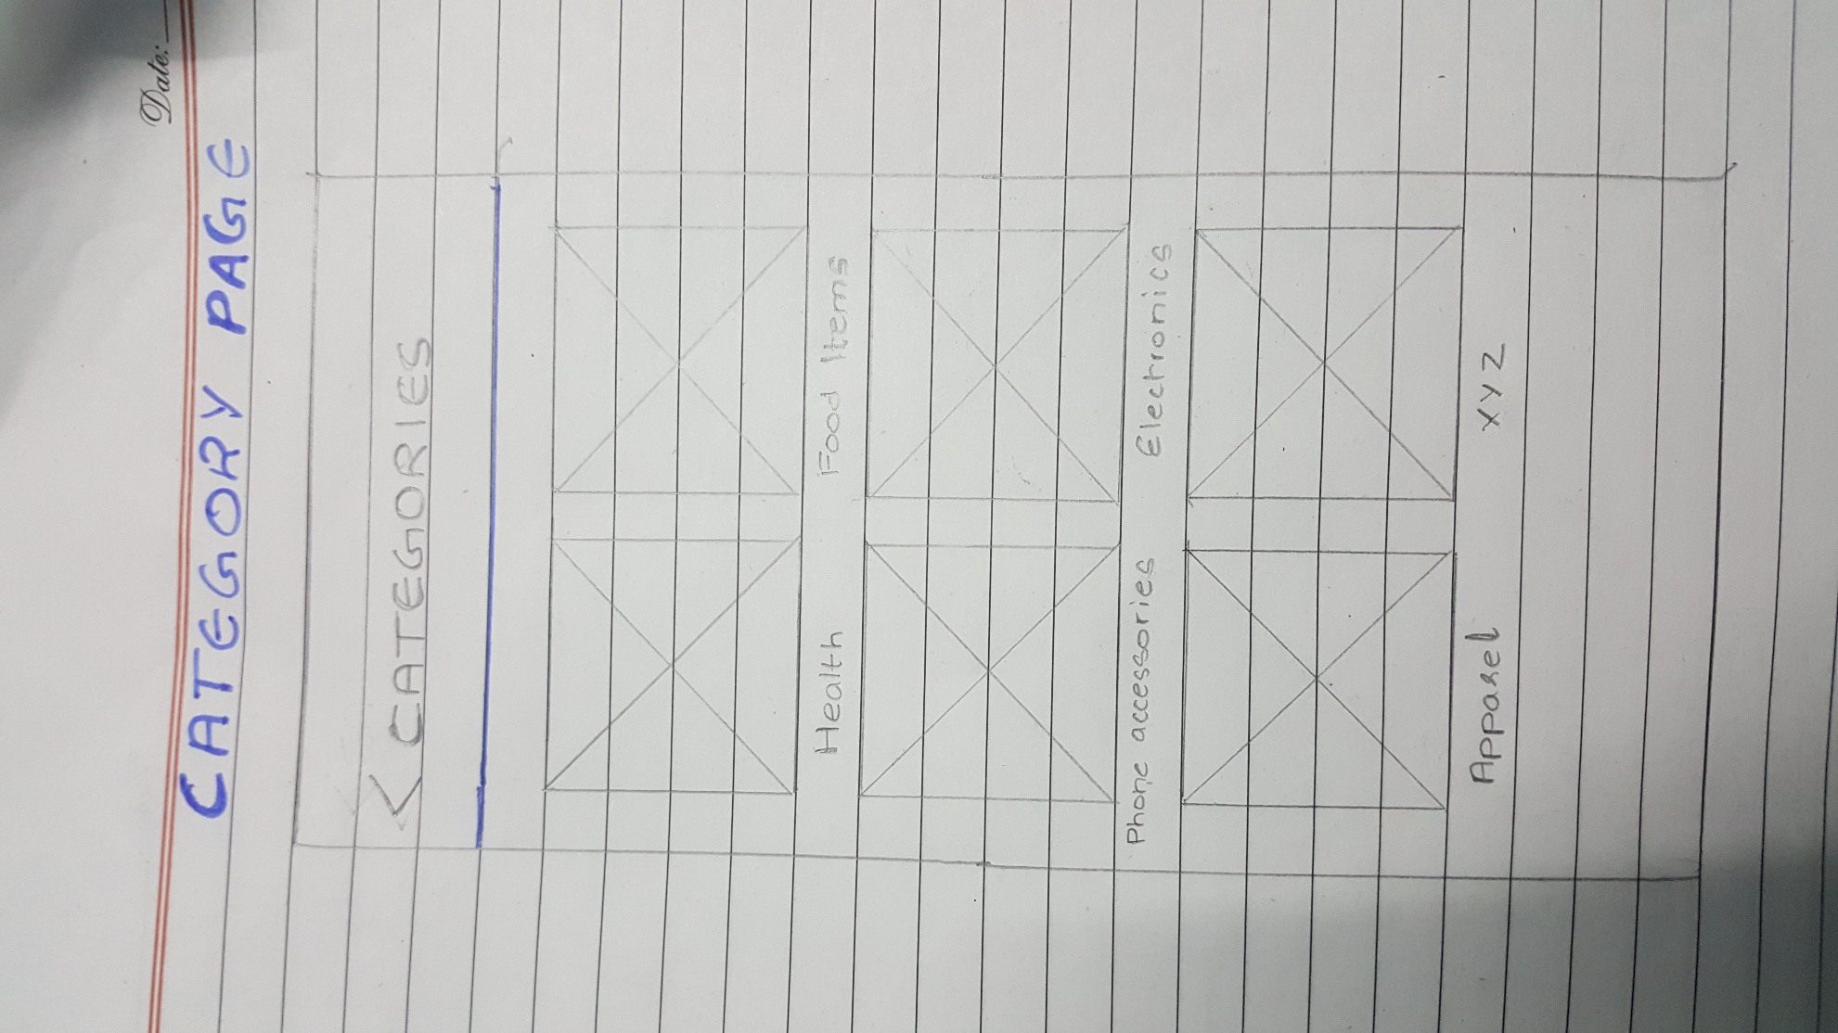

* **User Cart:**

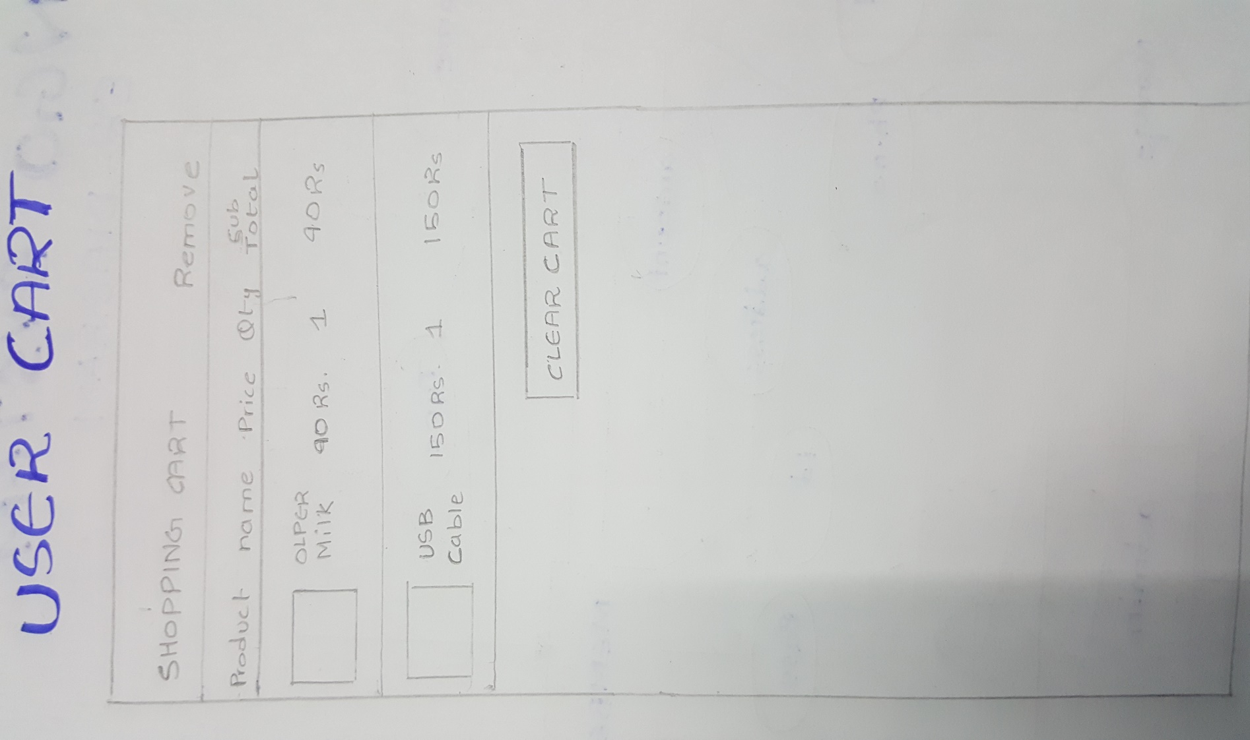

* **Proceed to Shipping**

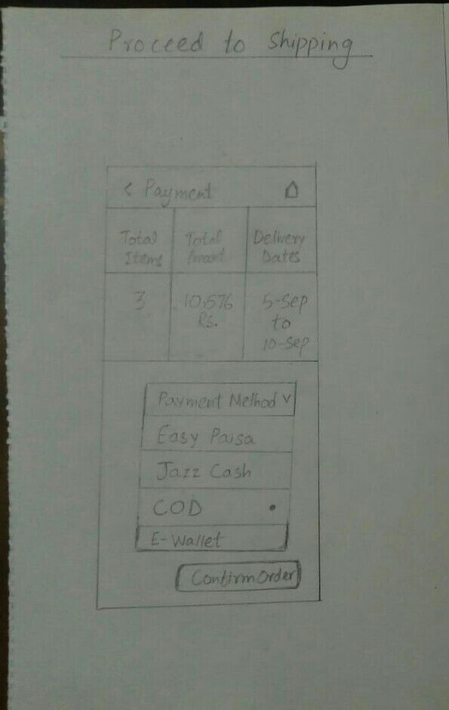

* **E-Wallet**

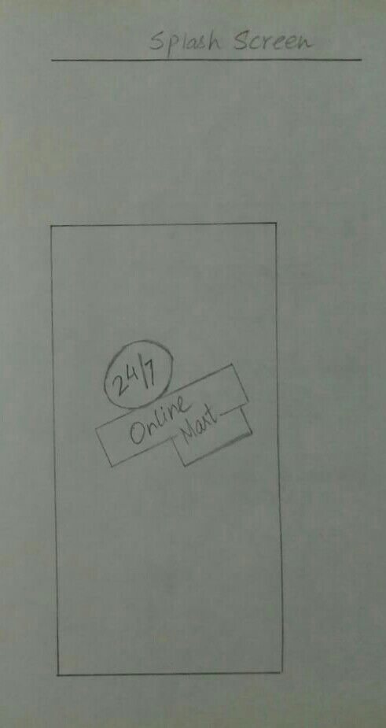

* **Account Setting**

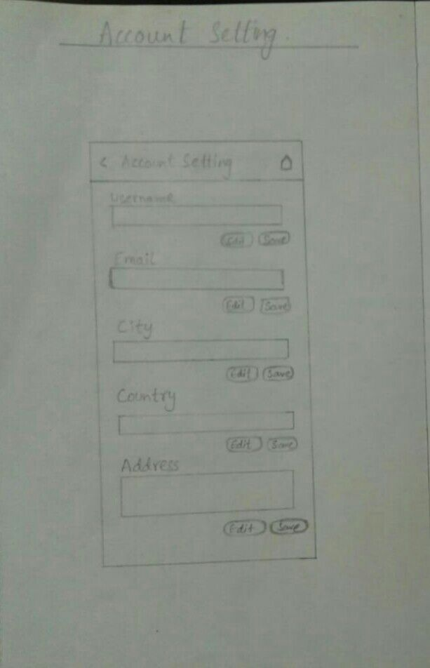

* **My Orders**

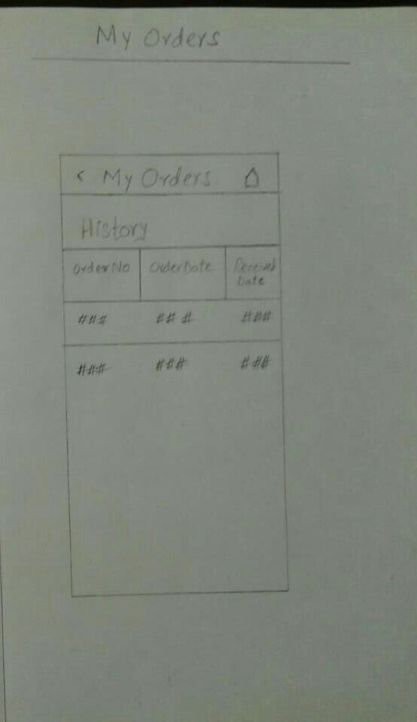

* **Signup Page**

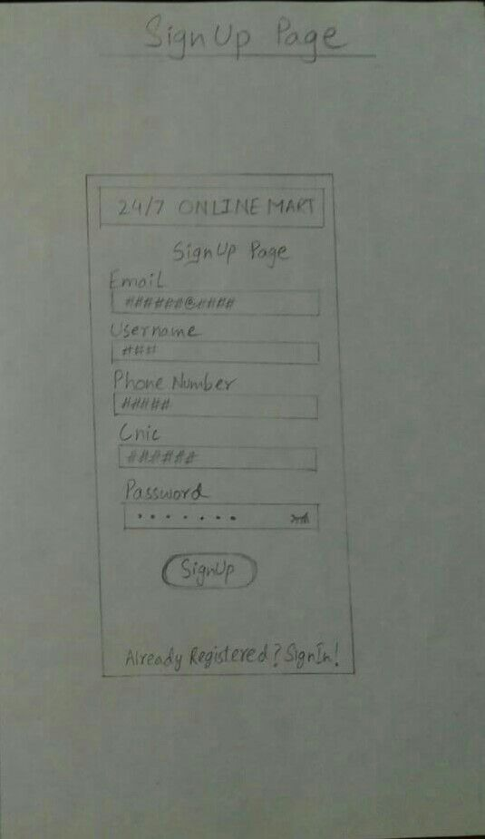

* **Sign-in Page**

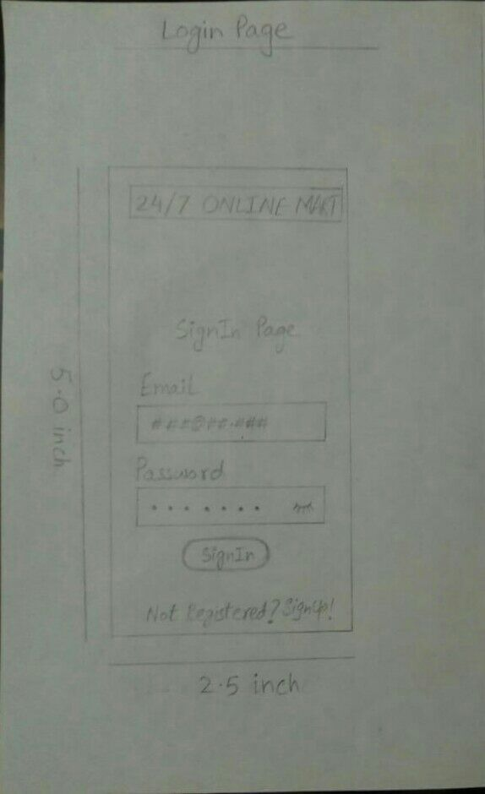

* **Home Screen**

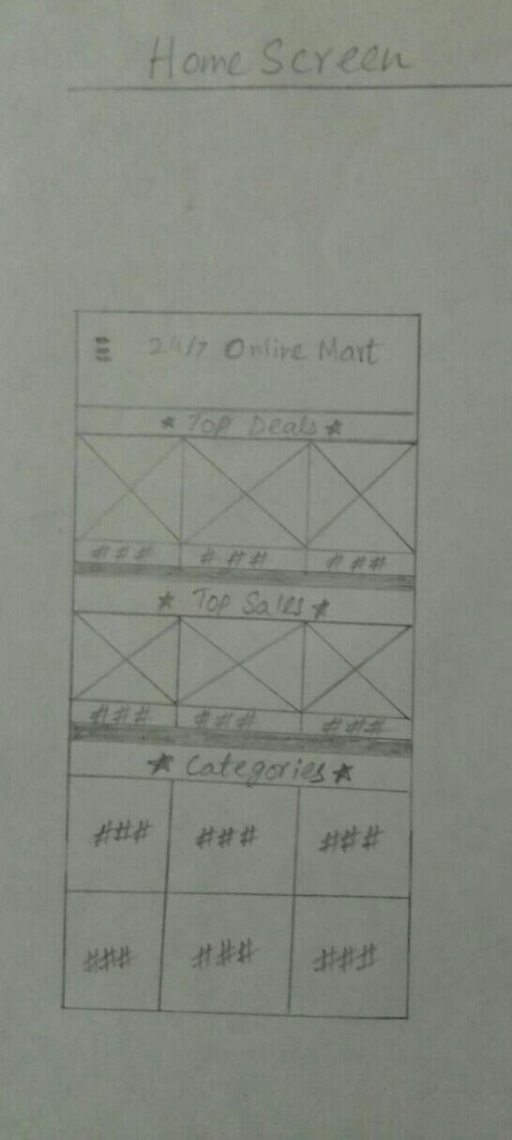

* **About Us**

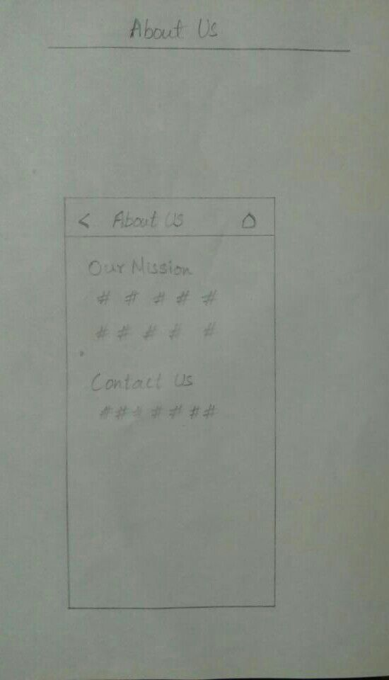

* **Splash Screen**



1. **WIREFRAMES**

* 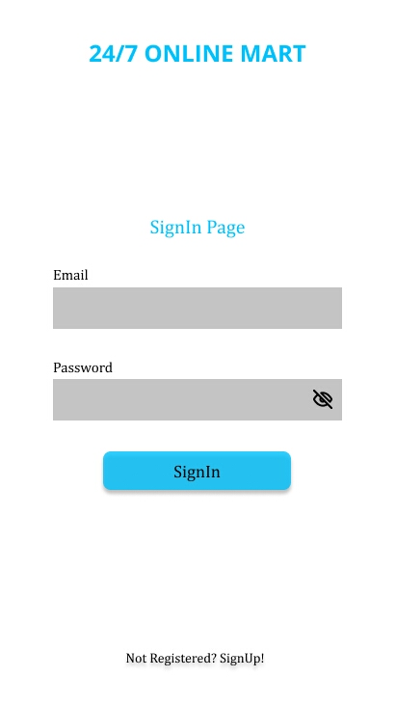**Sign in Page**
* **Sign Up Page**

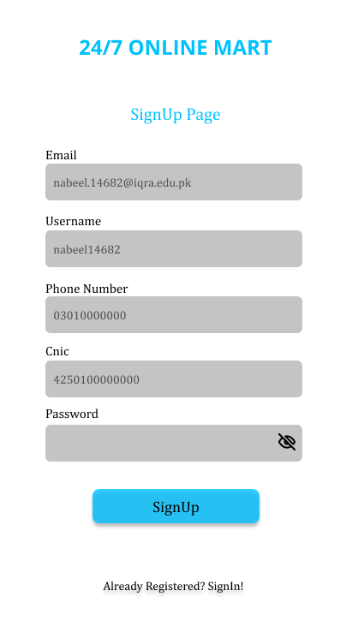

* 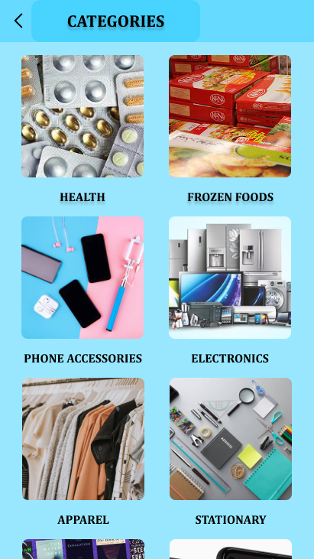**Category Page**
* 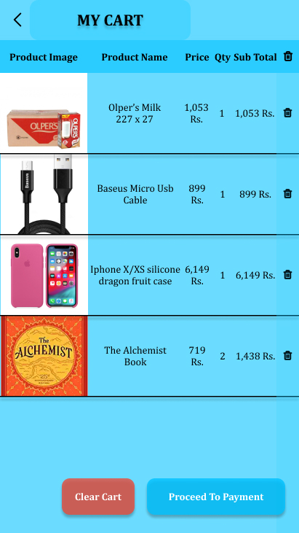**My Order Page**
* **Side Menu Page**

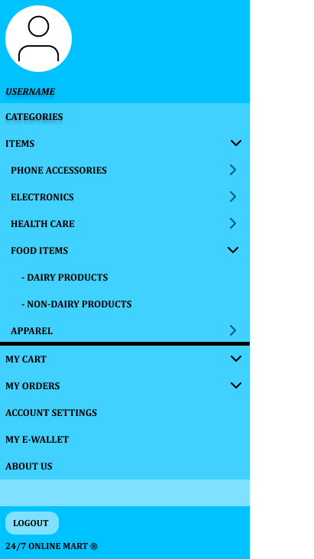

* **Account Setting Page**

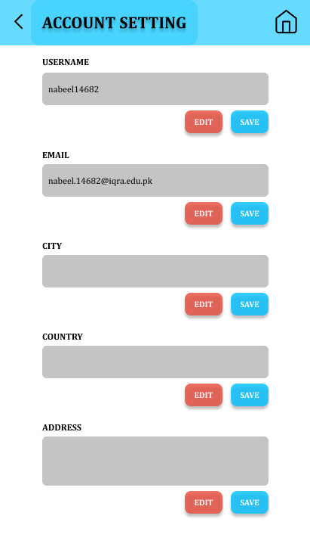

* **Payment method**

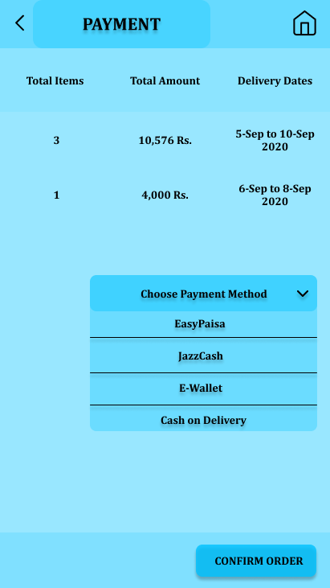

* **E-Wallet**

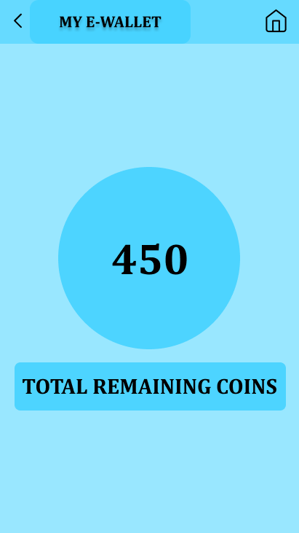

* **Home Screen Page**

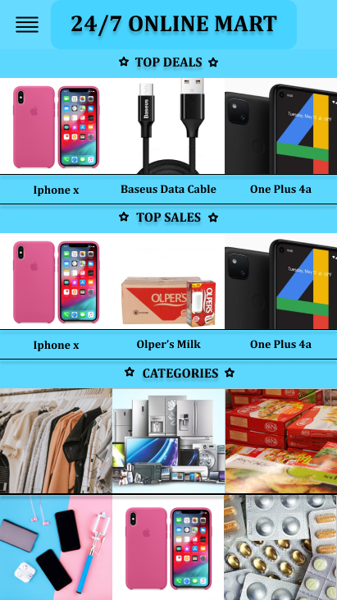

**\*\*\*END\*\*\***